|  |  |
| --- | --- |
| **Project Case** |  |
| COMP6583 | COMP6583001  Computer Graphics |
| **Computer Graphics** | **O242-COMP6583-NO01-00** |
| ***Valid on*** *Odd Semester Year 2023/2024* | **Revision 00** |

1. Kelompok tidak diperkenankan untuk:

*Members of the group are prohibited from:*

* + - Melihat sebagian atau seluruh jawaban kelompok lain,

*Seeing a part or the whole answer from other groups,*

* + - Menyadur sebagian atau seluruh jawaban dari buku, catatan, video, dan jenis referensi lainnya,

*Retell a part or the whole answer from books, notes, videos, and other references,*

* + - Menyadur sebagian atau seluruh jawaban dari internet,

*Retell a part or the whole answer from the internet,*

* + - Mengumpulkan jawaban yang tidak sesuai dengan tema soal,

*Submitting an answer with a different theme from the given case,*

* + - Melakukan tindakan yang menyebabkan jawaban dicontek oleh orang lain atau kelompok lain, baik disengaja maupun tidak disengaja,

*Doing action that could result the answer being copied by someone or other groups, intentionally or unintentionally,*

* + - Melakukan tindakan kecurangan lainnya.

*Committing other dishonest actions.*

1. Jika kelompok terbukti melakukan tindakan seperti yang dicantumkan pada butir ke-1, maka nilai mahasiswa dan/atau kelompok yang melakukan kecurangan, baik menyontek atau dicontek, akan dinolkan sesuai dengan peraturan yang berlaku.

*If it has been proven that a group has committed dishonest actions outlined in point 1 above, the whole group related to the incident, regardless of which one copies or has their answer copied, will be issued a score of zero according to the regulation.*

1. Jawaban yang dapat diterima dan dinilai adalah jawaban yang dikumpulkan sebelum batas waktu yang telah ditentukan.

*The answer must be submitted before the designated deadline to be accepted and graded,*

1. Jawaban akan dinilai berdasarkan teknik atau metode yang diajarkan pada kelas praktikum dengan menggunakan software yang sudah ditentukan.

*The scoring will be based on the materials taught during the practicum classes using the designated software. Using different software than requested may result in your answer not being graded.*

1. Jika Anda tidak membaca peraturan ini, maka Anda dianggap sudah membaca dan menyetujuinya.

*By taking this exam, you agree to these regulations, regardless of whether you have read it or not.*

1. Persentase penilaian untuk matakuliah ini adalah sebagai berikut:

*The score will be distributed as follows:*

|  |  |  |
| --- | --- | --- |
| **Tugas Mandiri**  *Assignment* | **Proyek**  *Project* | **UAP**  *Final Exam* |
| 40% | 60% | - |

1. Perangkat lunak yang digunakan pada matakuliah ini adalah sebagai berikut:

*This course uses the following software:*

|  |
| --- |
| **Software**  *Software* |
| Three JS r145  Visual Studio Code  Web Browser (Google Chrome) |

1. Ekstensi file yang harus dikumpulkan untuk matakuliah ini adalah sebagai berikut:

*Your answers must be in the following file extensions:*

|  |  |  |
| --- | --- | --- |
| **Tugas Mandiri**  *Assignment* | **Proyek**  *Project* | **UAP**  *Final Exam* |
| HTML, CSS, JS, Asset Files | HTML, CSS, JS, GLB, Asset Files | - |

1. File yang harus dikumpulkan adalah keseluruhan jawaban beserta dengan aset yang digunakan (gambar, audio, video, dll) dan dokumentasi proyek yang berisikan link referensi aset dan penjelasan mengenai aplikasi yang dibuat (terlampir bersama dengan soal).

*Include other files that can support your project, such as: all files in your project, other files (image, audio, video, etc.) used in your project, *.doc file (documentation of your project) that contains all pages in your project, reference links of additional files (image, audio, video, etc.) used in your project, the description about how to use your application, etc.*

## Soal

*Case*

**Plants NO Zombies**

Pop Corn, the game company that created the classic game **Plants NO Zombies** is planning on releasing its newest game release in 3D. You, as the idea designer, is asked to create a **prototype scene** based on the original game using **three.js**.

1. Project Structure

The project must contain a html file, javascript files, asset files, and the three.js library. You can get the three.js library from either one of these:

* Official website: <https://threejs.org/>
* Github: <https://github.com/mrdoob/three.js/>
* CDN link: <https://cdnjs.com/libraries/three.js>

For the html add this line of code snippet below.

|  |
| --- |
| <script src="[Path to index.js file]" type="module"></script>  <style>  *{ margin: 0; }  body{ overflow: hidden; }  </style> |

You are free to split your code into several different JavaScript files, but code the main logic for creating the scene inside “index.js” file.

1. Scene

Create a full screen scene that can be dynamically resized to fit the window. The scene also has shadow map enabled using PCFShadowMap as the shadow map type and anti-aliasing turned on.

1. Camera

There will be 2 types of cameras. Add a keyboard interaction to switch between the 2 cameras when pressing “C” on the keyboard. Create the cameras with the specifications below:

* 1. **Third Person Camera**

|  |  |
| --- | --- |
| Property | Value |
| Type | Perspective Camera |
| Field of View | 45 |
| Aspect Ratio | Window Ratio |
| Position | Vector3 (0, 15, 55) |

Make it so the camera can be **rotated** using **OrbitControls** and set the **Orbit Control** to focus on the position **Vector3 (0, 7, 0)**.

* 1. **First Person Camera**

|  |  |
| --- | --- |
| Property | Value |
| Type | Perspective Camera |
| Field of View | 45 |
| Aspect Ratio | Window Ratio |
| Position | Vector3 (-50, 15, 0) |

Make it so the camera focuses on the position **Vector3 (0, 15, 0)**.

1. Light

There will be 2 types of light sources. Add keyboard interaction to change between the day and night intensity for spotlight when pressing “Space Bar” on the keyboard. Create the light sources with the specifications below:

1. **Ambient Light**

|  |  |
| --- | --- |
| Property | Value |
| Intensity | 0.5 |
| Color | #FFFFFC |
| Cast Shadow | No |
| Position | Vector3 (0, 0, 0) |

1. **Spotlight**

|  |  |
| --- | --- |
| Property | Value |
| Intensity | 1.2 (day), 0.5 (night) |
| Color | #FFFFFF |
| Cast Shadow | Yes |
| Position | Vector3 (-80, 40, 0) |

1. Objects
2. **Grass**

For the grass object, below are the specifications.

|  |  |
| --- | --- |
| Property | Value |
| Geometry Type | Plane |
| Width | 100 |
| Height | 75 |
| Material Type | Mesh Standard Material |
| Position | Vector3 (0, 0, -7.5) |
| Receive Shadow | Yes |
| Texture Map |  |

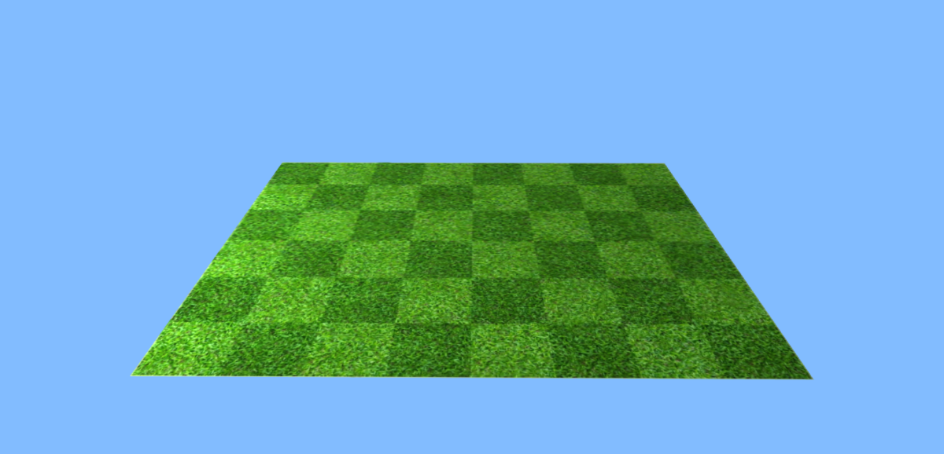

**Figure 1. Grass**

1. **Zombie**

For the **zombie** object, below are the specifications.

|  |  |
| --- | --- |
| Property | Value |
| Scale | Vector3 (60, 60, 60) |
| Position | Vector3 (10, 0, 0) |
| Receive Shadow | Yes |
| Cast Shadow | Yes |
| RotationY | -45° |

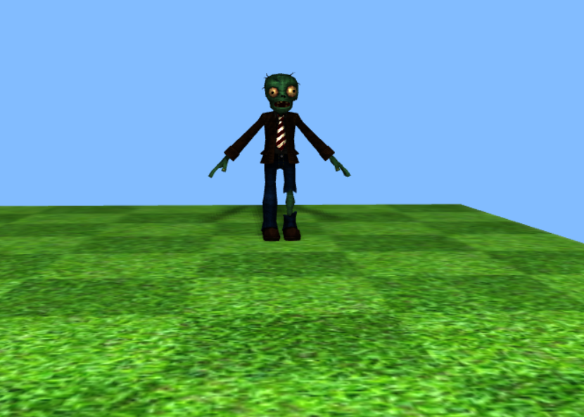

**Figure 2. Zombie**

1. **Text**

For the **text** object, below are the specifications.

|  |  |
| --- | --- |
| Property | Value |
| String | Plants NO Zombies |
| Font Type | Gentilis bold |
| Material Type | Mesh Phong Material |
| Position | Vector3 (-55, 20, -50) |
| Color | #CCB7B6 |

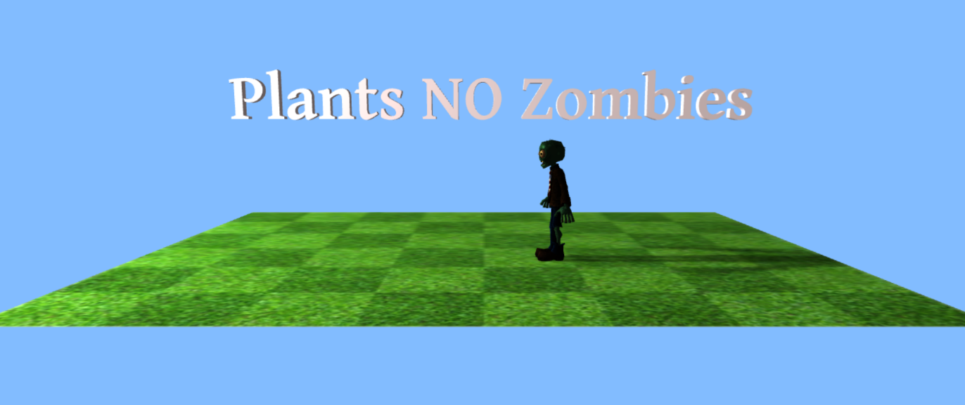

**Figure 3. Text**

1. **Fence**

There will be **5 fences** objects, below are the specifications.

|  |  |
| --- | --- |
| Propert | Value |
| Scale | Vector3 (10, 10, 10) |
| Position Fence 1 | Vector3 (-40, 8.5, -44) |
| Position Fence 2 | Vector3 (-20, 8.5, -44) |
| Position Fence 3 | Vector3 (0, 8.5, -44) |
| Position Fence 4 | Vector3 (20, 8.5, -44) |
| Position Fence 5 | Vector3 (40, 8.5, -44) |
| Receive Shadow | Yes |
| Cast Shadow | Yes |

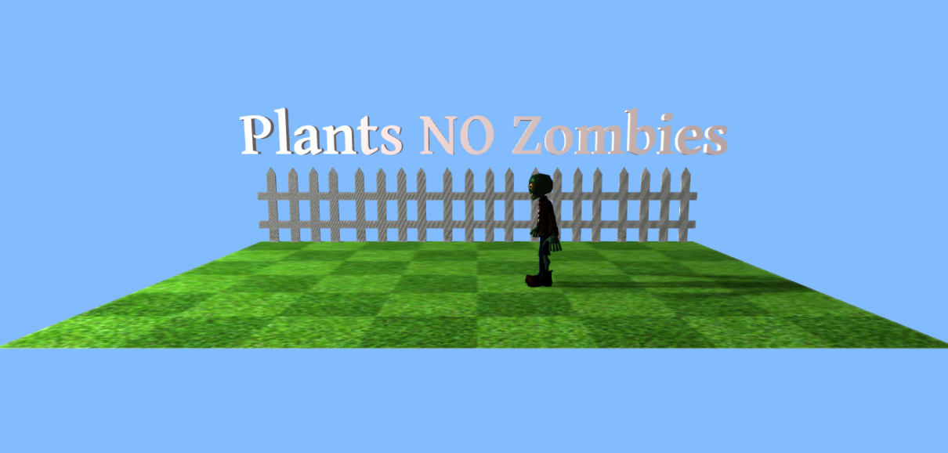

**Figure 4. Fence**

1. **Peashooter**

The **peashooter** consists of a few parts:

* 1. **Head**

Create **head object** for the **peashooter** with the specifications below.

|  |  |
| --- | --- |
| Property | Value |
| Geometry Type | Sphere |
| Radius | 2.5 |
| Width Segments | 64 |
| Material Type | Mesh Phong Material |
| Color | #52D017 |
| Position | Vector3 (-30, 10, 0) |
| Cast Shadow | Yes |

* 1. **Mouth**

Create **mouth object** for the **peashooter** with the specifications below.

|  |  |
| --- | --- |
| Property | Value |
| Geometry Type | Cylinder |
| Top Radius | 0.5 |
| Bottom Radius | 1 |
| Height | 2.5 |
| Radial Segments | 64 |
| Height Segments | 64 |
| Open Ended | Yes |
| Material Type | Mesh Phong Material |
| Color | #52D017 |
| Position | Vector3 (-26.5, 10, 0) |
| Cast Shadow | Yes |
| Z-rotation | 90° |

* 1. **Head Top**

Create **a head top object** for the **peashooter** with the specifications below.

|  |  |
| --- | --- |
| Property | Value |
| Geometry Type | Cone |
| Radius | 1 |
| Height | 2.5 |
| Radial Segments | 64 |
| Material Type | Mesh Phong Material |
| Color | #43B000 |
| Position | Vector3 (-32.5, 12, 0) |
| Cast Shadow | Yes |
| Z-rotation | 45° |

* 1. **Eyes**

Create **2 eyes object** for the **peashooter** with identical specifications below.

|  |  |
| --- | --- |
| Property | Value |
| Geometry Type | Sphere |
| Radius | 0.5 |
| Width Segments | 64 |
| Material Type | Mesh Phong Material |
| Color | #000000 |
| Position1 | Vector3 (-28.5, 11, -1.5) |
| Position2 | Vector3 (-28.5, 11, 1.5) |
| Cast Shadow | Yes |

* 1. **Trunk**

Create **trunk object** for the **peashooter** with the specifications below.

|  |  |
| --- | --- |
| Property | Value |
| Geometry Type | Cylinder |
| Top Radius | 0.75 |
| Bottom Radius | 0.75 |
| Height | 10 |
| Radial Segments | 64 |
| Height Segments | 64 |
| Open Ended | Yes |
| Material Type | Mesh Phong Material |
| Color | #4BBF15 |
| Position | Vector3 (-30, 5, 0) |
| Cast Shadow | Yes |

**Figure 5. Peashooter**

1. **Wallnut**

Create a **wallnut** object with the specifications below:

|  |  |
| --- | --- |
| Property | Value |
| Geometry Type | Cylinder |
| Top Radius | 4.5 |
| Bottom Radius | 4.5 |
| Height | 3 |
| Radial Segments | 64 |
| Height Segments | 64 |
| Open Ended | Yes |
| Material Type | Mesh Phong Material |
| Color | #4BBF15 |
| Position | Vector3 (-17.5, 4.5, 0) |
| Cast Shadow | Yes |
| Z-rotation | 90° |
| Texture Map |  |

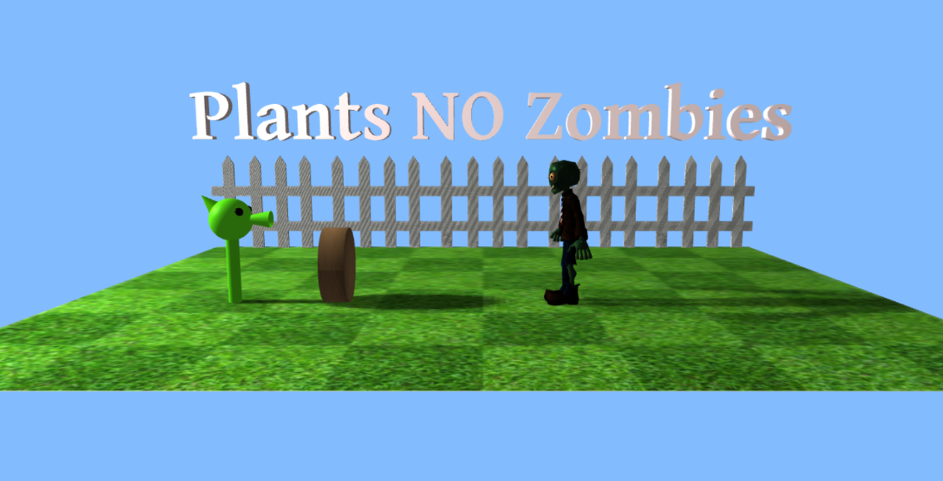

**Figure 6. Wallnut**

1. Skybox

There will be 2 types of skyboxes. Add keyboard interaction to change between day and night skybox when pressing “Space Bar” on the keyboard. Create the skyboxes with the specifications below:

* 1. **Day** (Default)

|  |  |
| --- | --- |
| Property | Value |
| Size | 1000, 1000, 1000 |
| Texture  (Sequence: ft, bk, up, dn, rt, lf) |  |

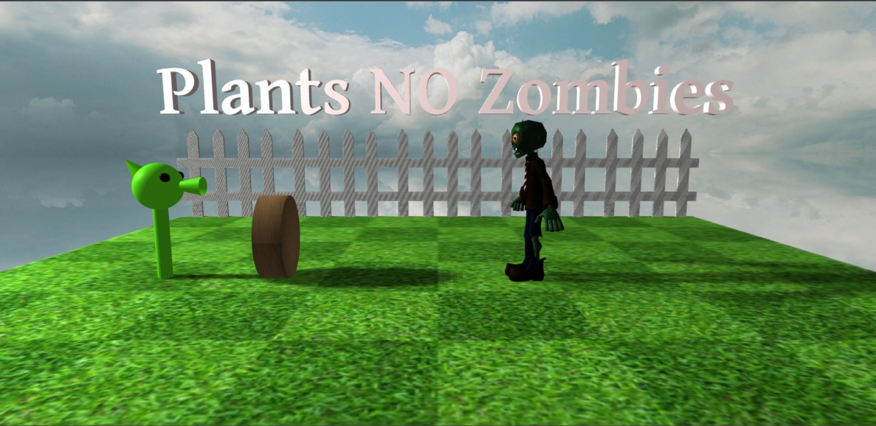

**Figure 7. Day**

* 1. **Night**

|  |  |
| --- | --- |
| Property | Value |
| Size | 1000, 1000, 1000 |
| Texture |  |

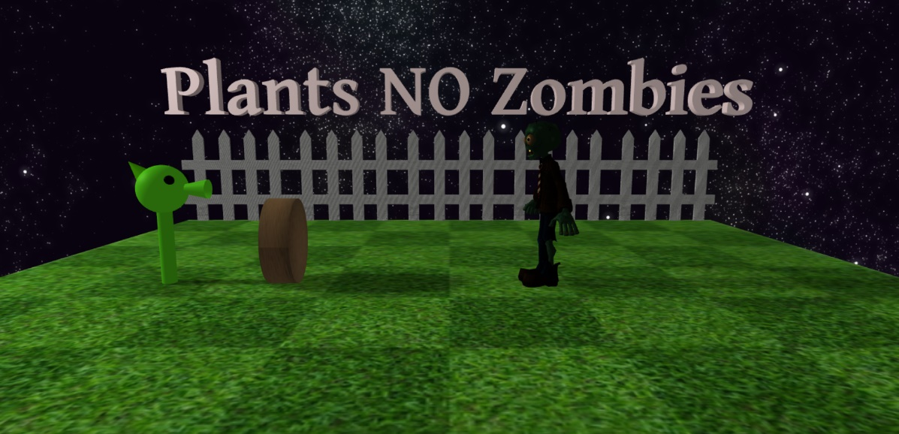

**Figure 8. Night**

1. Dynamic Object

Create a dynamic object (pea projectile) with raycast interaction. When the peashooter’s head object is clicked, spawn a pea projectile that will move forward from the peashooter’s head. When the projectile hits the zombie object, remove the pea projectile. Validate only one pea projectile can exist in the scene.

Create the pea projectile with specifications below:

|  |  |
| --- | --- |
| Property | Value |
| Geometry Type | Sphere |
| Radius | 1 |
| Width Segments | 64 |
| Material Type | Mesh Phong Material |
| Color | #52D017 |
| Cast Shadow | Yes |
| Spawn Position | Vector3 (-27, 10, 0) |

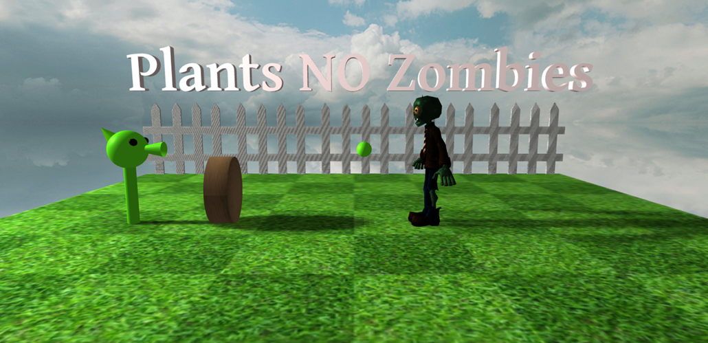

**Figure 8. Projectile**

**References:**

<https://render.fineartamerica.com/images/rendered/default/poster/10/8/break/images/artworkimages/medium/2/popcorn-texture-marcus-jules.jpg>

<https://thumbs.dreamstime.com/b/green-grass-field-background-soccer-football-sports-lawn-pattern-texture-close-up-image-142564163.jpg>

<https://skfb.ly/6ZZNq>

https://skfb.ly/o7HxM

<https://opengameart.org/content/cloudy-skyboxes>

<https://opengameart.org/content/night-sky-stars-and-galaxies>